**Abstract**

Intraguild predation (IGP) is common in natural and human-managed systems and plays a critical role in food web dynamics. Although studies have documented the occurrence of IGP across a wide range of arthropod predator taxa, quantitative understanding regarding the degree/intensity of IGP remains lacking. Here, I propose an experimental framework combining controlled feeding trials and stable isotope analysis to quantify the degree of IGP in a three-species omnivorous food web (top predator + mesopredator + shared prey) in the field. The degree of IGP is defined as the proportion (in number) of mesopredator consumed in the total diet (shared prey + mesopredator) of top predator. Feeding trials along with stable isotope analysis are used to construct a standard IGP curve, to which the nitrogen isotope signatures of field-sampled top predator individuals are interpolated to estimate the degree of IGP in the field. The proposed framework leverages the strengths of different experimental approaches to studying trophic interactions, providing a tool for quantifying IGP in a more accurate (controlled feeding trials and standard IGP curve) and realistic (stable isotope analysis of field samples) fashion. If successful, the current framework can be extended to food webs involving more complex interactions (e.g., cannibalism and multiple shared prey) and further complemented with other approaches (e.g., molecular gut content analysis) to capture a more complete picture of IGP dynamics in the field.

**Key words**

intraguild predation, food webs, omnivory, generalist predators, stable isotope analysis

**Introduction**

Intraguild predation (IGP) is common in natural and human-managed ecosystems (Polis and Holt 1992, Müller and Brodeur 2002, Arim and Marquet 2004) and is documented across a wide range of arthropod predator taxa (Polis et al. 1989, Gagnon et al. 2011). IGP could substantially affect the abundance and distribution of interacting species, generating ecological and evolutionary consequences for food web dynamics (Polis et al. 1989).

Previous studies have recorded the occurrence of IGP among arthropod predators through field observations of diet compositions (e.g., Nyffeler and Sunderland 2003, Birkhofer and Wolters 2012). Manipulative experiments (e.g., field cages) have also been used to assess the intensity of IGP (e.g., Denno et al. 2004) and could reveal the mechanisms underlying predator-prey interactions, allowing for strong causal inferences about IGP. Nonetheless, the confined settings in these experiments may potentially alter the encounter rates between organisms, thus leading to biased results (Uiterwaal et al. 2019).

Stable isotopes, particularly nitrogen isotope signatures (δ15N), have been used to estimate the trophic levels of predators for inferences about IGP (e.g., Wise et al. 2006). It is suggested that IGP would increase the δ15N of predators (Ponsard and Arditi 2000). For example, Rickers et al. (2006) conducted feeding experiments on wolf spiders (*Alopecosa cuneata*) and found a higher δ15N of these top predators in IGP treatment. However, the study did not quantify the degree of IGP as the IGP treatment was binary (absence vs. presence of mesopredator) with constant numbers of shared prey and mesopredator. On top of that, the trophic levels of top predators in previous studies were often calculated based on assumed trophic discrimination factors (TDFs) (Svanbäck et al. 2015). Since TDFs are quite taxon-specific (Caut et al. 2009), this could lead to incorrect trophic level estimates and inferences about IGP in the field.

Recently, researchers have applied molecular gut content analysis and immunological techniques to reliably detect the presence of certain food items in predators’ diet (Gagnon et al. 2011), allowing for calculating the incidence rates of IGP (i.e., the percentage of top predator individuals with mesopredator detected in the gut contents). Nonetheless, the incidence rates may not necessarily reflect the degree of IGP in the system (Raso et al. 2014). For example, it is possible that a high percentage of top predator individuals feed on mesopredator yet each of them consumes on average a low proportion of mesopredator in the diet. In this case, a high incidence rate of IGP only provides an incomplete picture of IGP dynamics.

Quantifying IGP is a critical step towards a deeper understanding of food web dynamics. Research has attempted to predict the intensity/degree of IGP based on allometric theory (Schneider et al. 2012), yet empirical evidence remains scarce. To address this gap, I propose an experimental framework combining controlled feeding trials and stable isotope analysis of field samples to estimate the degree of IGP in a three-species omnivorous food web (top predator + mesopredator + shared prey). The degree of IGP is defined herein as the proportion (in number) of mesopredator consumed in the total diet (mesopredator + shared prey) of top predator. The feeding trials will experimentally link different levels of mesopredator consumption by top predator to the changes in top predator’s nitrogen isotope signatures via a IGP standard curve, to which the nitrogen isotope signatures of field-collected top predator individuals are interpolated to estimate the degree of IGP in the field.

**The proposed experimental framework**

The proposed experimental framework consists of three main stages: (1) first feeding trial for stable isotope calibration of focal organisms, (2) second feeding trial for construction of standard IGP curve, and (3) collection of field samples for IGP estimation. I will illustrate the framework using an example of a terrestrial arthropod food web involving a spider top predator, a spider mesopredator, and a planthopper shared prey (Fig. 1a) in the following paragraphs.

The first feeding trial is to calibrate the nitrogen isotope signatures of the focal organisms. In this trial, the top predator and mesopredator are fed the shared prey for a period of time (Fig. 1b). The actual duration of feeding may vary depending on the species. For arthropods, a period of 5–10 days will allow predators to incorporate isotope signatures into their tissues and reach an isotopic equilibrium state with the shared prey (Quinby et al. 2020).

The second feeding trial is to simulate a full range of omnivory that the top predator may exhibit in the field for constructing a standard IGP curve. In this trial, the top predator is fed mixed diets with different proportions of shared prey and mesopredator individuals from the first feeding trial: (1) 100% shared prey, (2) 75% shared prey + 25% mesopredator, (3) 50% shared prey + 50% mesopredator, (4) 25% shared prey + 75% mesopredator, and (5) 100% mesopredator (Fig. 1c). The actual numbers of shared prey and mesopredator supplied can be determined based on their field densities. To avoid the potential interfering effects of mesopredator feeding on the shared prey, the prey items are presented to the top predator one at a time in a randomized sequence instead of all at once. This also allows the researcher to ensure that a prey item is consumed by the top predator before the next item is presented.

At the end of the second trial (same duration as the first feeding trial to allow for the incorporation of prey isotope signatures into predator’s tissues), the top predator individuals in each diet treatment as well as the shared prey are prepared for stable isotope analysis to obtain their δ15N values. The difference in δ15N between the top predator and the shared prey (baseline) is computed (δ15N*predator*─ δ15N*prey*; experimental Δ15N), and a standard curve is constructed by fitting a non-linear regression on the experimental Δ15N against the proportion of mesopredator in the diet (Fig. 1d).

Finally, field samples of top predator and shared prey are collected for stable isotope analysis. The shared prey individuals are pooled to obtain a single baseline δ15N, while the δ15N of top predator individuals are analyzed separately and thus each predator has its own empirical Δ15N. The degree of IGP at the individual level can then be estimated by interpolating the individual empirical Δ15N to the standard IGP curve (Fig. 1e). The mean and standard error of these individual IGP estimates can provide a measure of the average degree of IGP in the field and the uncertainty around the mean estimate at the population level.

A hypothetical example of standard IGP curve construction and estimation of IGP with field samples is shown in Fig. 2. In this example, each diet treatment contains five top predator individuals, each of which is fed 12 prey items during the feeding period. After the feeding trial, the experimental Δ15N of these predator individuals are determined and used to construct a standard IGP curve (Fig. 2a). 20 top predator and 30 shared prey individuals (pooled) are then collected from the field for stable isotope analysis and determination of empirical Δ15N. An IGP estimate is calculated for each top predator individual so that there will be a total of 20 estimates, which are further averaged to quantify the degree of IGP at the population level (Fig. 2b).

**Application**

The proposed framework leverages the strengths of different approaches to studying trophic interactions—the controlled feeding trials combined with stable isotope analysis can yield accurate experimental Δ15N for constructing a standard IGP curve, whereas the empirical Δ15N derived from field samples reflects the trophic interactions under natural settings. Additionally, the framework is robust to variations in background isotope signatures because the IGP estimation is based on the difference in nitrogen isotope signatures (Δ15N) rather than the original values (δ15N), thus allowing for comparisons across sites or systems with distinct background isotope signatures.

The framework can be implemented along environmental gradients or under different field treatments to investigate how various abiotic and biotic factors affect IGP interactions. For instance, one can quantify and compare the degree of IGP across altitudes to examine whether omnivory changes with temperature, precipitation, or vegetation. Moreover, this study uses a spider as an example of top predator, but the framework applies to other generalist predators as well, provided that they are amenable to feeding trials and easy to collect in the field.

The systems ideal for implementing the proposed framework are those with clear IGP patterns and relatively simple trophic interaction networks, which can minimize the potential interfering effects of non-focal species on the IGP interactions among focal organisms (Vance-Chalcraft et al. 2007). One of such systems is agricultural system, in which IGP occurs frequently (Polis et al. 1989, Rosenheim et al. 1995) and the food webs are generally less complex compared with most natural ecosystems. Furthermore, understanding the degree of IGP in agricultural field can have useful implications for practitioners, for example, evaluation of the effectiveness of biocontrol agents in pest control programs (Müller and Brodeur 2002).

A potential limitation of the proposed framework is that there could be multiple mesopredators and shared prey with different isotope signatures in the field, which may introduce variations into the IGP estimates for individual top predators. Yet, given sufficiently large field samples, the average of these individual estimates should fairly reflect the overall IGP patterns in the field at the population level. Therefore, although the isotope signatures of top predators could represent multiple dietary items over time and space, the framework still provides a tool for assessing IGP in a more quantitative and realistic fashion.

A better quantitative understanding of IGP can offer critical insights into the complex predator-predator-prey trophic interactions and help predict the community structure and stability (Arim and Marquet 2004, Pahl et al. 2020). Albeit conceptual at this stage, I am optimistic about validating the proposed framework with real data and further refining it. If proven successful, the current framework can be extended to food webs involving more complex interactions (e.g., cannibalism and multiple shared prey) and complemented with other approaches (e.g., molecular gut content analysis) to better elucidate the IGP dynamics in the field.

Reference

Arim, M. and Marquet, P. A. 2004. Intraguild predation: a widespread interaction related to species biology. - Ecol. Lett. 7: 557-564.

Birkhofer, K. and Wolters, V. 2012. The global relationship between climate, net primary production and the diet of spiders. - Wiley Online Library, pp. 100-108.

Caut, S. et al. 2009. Variation in discrimination factors (Δ15N and Δ13C): the effect of diet isotopic values and applications for diet reconstruction. - Journal of Applied Ecology 46: 443-453.

Denno, R. F. et al. 2004. Interactions between a hunting spider and a web‐builder: consequences of intraguild predation and cannibalism for prey suppression. - Ecological entomology 29: 566-577.

Gagnon, A.-È. et al. 2011. The ubiquity of intraguild predation among predatory arthropods. - PLoS One 6: e28061.

Müller, C. B. and Brodeur, J. 2002. Intraguild predation in biological control and conservation biology. - Biological Control 25: 216-223.

Nyffeler, M. and Sunderland, K. D. 2003. Composition, abundance and pest control potential of spider communities in agroecosystems: a comparison of European and US studies. - Agric., Ecosyst. Environ. 95: 579-612.

Pahl, K. B. et al. 2020. Measuring the occurrence and strength of intraguild predation in modern food webs. - Food Webs: e00165.

Polis, G. A. and Holt, R. D. 1992. Intraguild predation: the dynamics of complex trophic interactions. - Trends in ecology & evolution 7: 151-154.

Polis, G. A. et al. 1989. The ecology and evolution of intraguild predation: potential competitors that eat each other. - Annual review of ecology and systematics 20: 297-330.

Ponsard, S. and Arditi, R. 2000. What can stable isotopes (δ15N and δ13C) tell about the food web of soil macro‐invertebrates? - Ecology 81: 852-864.

Quinby, B. M. et al. 2020. Stable isotope ecology in insects: a review. - Ecol. Entomol. 45: 1231-1246.

Raso, L. et al. 2014. Intraguild predation in pioneer predator communities of alpine glacier forelands. - Molecular ecology 23: 3744-3754.

Rickers, S. et al. 2006. Stable isotope analyses document intraguild predation in wolf spiders (Araneae: Lycosidae) and underline beneficial effects of alternative prey and microhabitat structure on intraguild prey survival. - Oikos 114: 471-478.

Rosenheim, J. A. et al. 1995. Intraguild predation among biological-control agents: theory and evidence. - Biol. Control 5: 303-335.

Schneider, F. D. et al. 2012. Body mass constraints on feeding rates determine the consequences of predator loss. - Ecol. Lett. 15: 436-443.

Svanbäck, R. et al. 2015. Individuals in food webs: the relationships between trophic position, omnivory and among-individual diet variation. - Oecologia 178: 103-114.

Uiterwaal, S. F. et al. 2019. Arena size modulates functional responses via behavioral mechanisms. - Behav. Ecol. 30: 483-489.

Vance-Chalcraft, H. D. et al. 2007. The influence of intraguild predation on prey suppression and prey release: a meta‐analysis. - Ecology 88: 2689-2696.

Wise, D. H. et al. 2006. Using stable isotopes to reveal shifts in prey consumption by generalist predators. - Ecological Applications 16: 865-876.

**Figure legends**

Figure 1.A schematic diagram of the proposed experimental framework for quantifying the degree of intraguild predation (IGP) in a three-species omnivorous food web involving a spider top predator, a spider mesopredator, and a planthopper shared prey. See “The proposed experimental framework” for detailed descriptions of the steps in the framework.

Figure 2. A hypothetical example of (a) standard IGP curve construction using data collected from the second feeding trial and (b) estimation of IGP with field samples of top predator and shared prey. *N*: number of shared prey/mesopredator in the mixed diet; *P*: proportion of mesopredator consumed (%).

**Figures**

Figure 1.

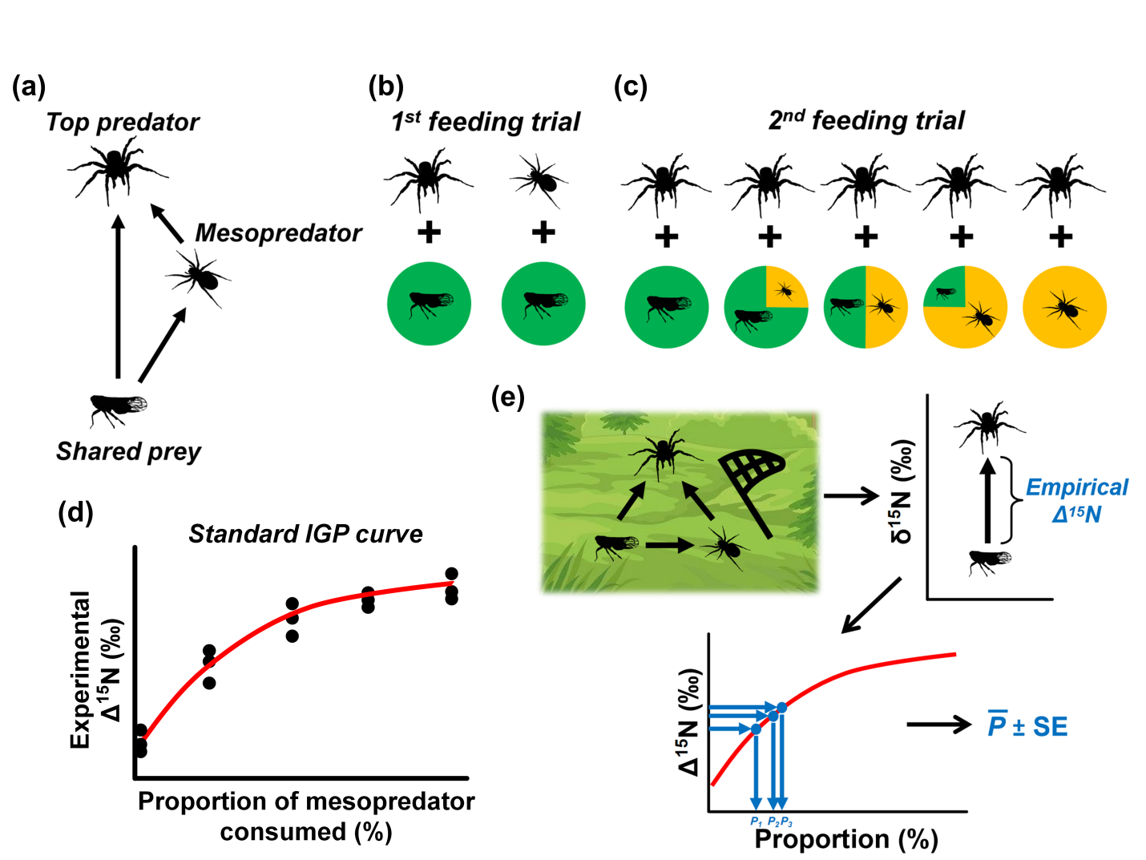

Figure 2.

